# kMIS3720 - Milestone #3

**Team F:**, Allison Escott, Bishoy Soliman, Franco Bazzini, Katelyn Tropeano, Katie Houskeeper, Vishnu Priya Dendukuri

**Problem description:** We will work to solve the issue of a hospital admitting more patients than the number of beds available. We will create a database that stores information regarding which rooms are currently occupied and which are still available.

**Conceptual model:**

Patients:

* PatientID - PK
* FirstName
* LastName
* DOB
* Gender
* DateAdmitted
* City
* State
* Country
* ZipCode
* InsuranceName

Nurse:

* NurseID - PK
* FirstName
* LastName
* YearsPracticing
* Availability

Doctor:

* DoctorID - PK
* YearsPracticing
* FirstName
* LastName
* Availability

Room:

* RoomID -PK
* NumberOfBeds
* NoBedsAvailable
* RoomType

Department:

* DepartmentID - PK
* DepartmentName

**E-R Diagram:**

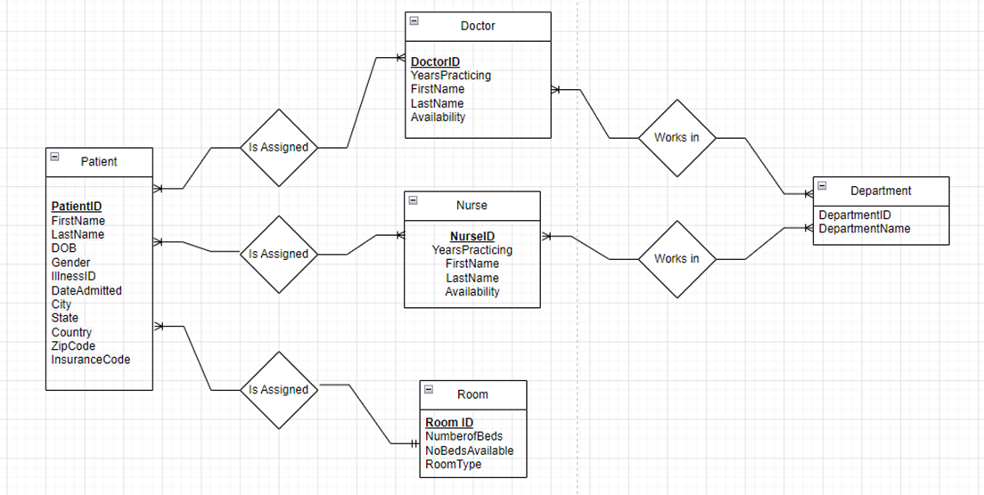

**Logical model:**

tbPatients (**PatientID**, FirstName, LastName, DOB, Gender*,* DateAdmitted, City, State, Country, ZipCode, InsuranceName, *DoctorID*, *NurseID*, *RoomID*)

tbNurse (**NurseID***, DepartmentID* , FirstName, LastName, YearsPracticing, Availability)

tbDoctor (**DoctorID***, DepartmentID .*YearsPracticing, FirstName, LastName, Availability)

tbRoom (**RoomID**, NumberOfBeds, NoBedsAvailable, RoomType)

tbDepartment(**DepartmentID**, DepartmentName)

**Data dictionary:**

| **Patient:** | | |
| --- | --- | --- |
|  | | |
| **Column** | **Data Type** | **Description** |
| **PatientID** | **Short Text** | **Primary key of the Patient Table** |
| **FirstName** | **Short Text** | **First name of**  **the patient** |
| **LastName** | **Short Text** | **Last name of the patient** |
| **DOB** | **Date/Time** | **DOB of the**  **patient** |
| **Gender** | **Short Text** | **Gender of the patient** |
| **DateAdmitted** | **Date/Time** | **Date admitted**  **into hospital** |
| **City** | **Short Text** | **City of patient** |
| **State** | **Short Text** | **State of the**  **patient** |
| **Country** | **Short Text** | **Country of the patient** |
| **ZipCode** | **Short Text** | **Zip code of the**  **patient** |
| **InsuranceName** | **Short Text** | **Name of the insurance company** |
| **DoctorID** | **Short Text** | **Foreign key referencing Doctor ID from the Doctor Table** |
| **NurseID** | **Short Text** | **Foreign key referencing Nurse ID from the Nurse table** |
| **RoomID** | **Short Text** | **Foreign key referencing Room ID from the Room table** |

**Nurse:**

| **Column** | **Data Type** | **Description** |
| --- | --- | --- |
| **NurseID** | **Short Text** | **Primary key of the Nurse Table** |
| **DepartmentID** | **Short Text** | **Foreign Key referencing Department** |
| **FirstName** | **Short Text** | **First name of the nurse** |
| **LastName** | **Short Text** | **Last name of the nurse** |
| **YearsPracticing** | **Number** | **Number of years of experience** |
| **Availability** | **Yes/No** | **Checking if the doctor is available or not** |

**Doctor:**

| **Column** | **Data Type** | **Description** |
| --- | --- | --- |
| **DoctorID** | **Short Text** | **Primary key of the Doctor Table** |
| **FirstName** | **Short Text** | **First name of the nurse** |
| **LastName** | **Short Text** | **Last name of the nurse** |
| **YearsPracticing** | **Number** | **Number of years of experience** |
| **Availability** | **Yes/No** | **Checking if the doctor is available or not** |
| **DepartmentID** | **Short Text** | **Foreign Key referencing Department** |

**Room:**

| **Column** | **Data Type** | **Description** |
| --- | --- | --- |
| **RoomID** | **Short Text** | **Primary key of the Room Table** |
| **NumberOfBeds** | **Number** | **Number of Beds in the room** |
| **NoBedsAvailable** | **Number** | **Number of beds available in the room** |
| **RoomType** | **Short Text** | **Description of room type** |

**Department:**

| **Column** | **Data Type** | **Description** |
| --- | --- | --- |
| **DepartmentID** | **Short Text** | **Primary key of the Department Table** |
| **DepartmentName** | **Short Text** | **Name of the department** |

**A list of switchboards to use in your database GUI**

* Shows what doctors are assigned to which patients
* Show what nurses are assigned to patients
* Open doctor information
* Be able to see the available doctors
* Open patient info

All of these switchboards allow for easy access to information in a clear way.

